**Travelling Book**

**‘Anything Goes’**

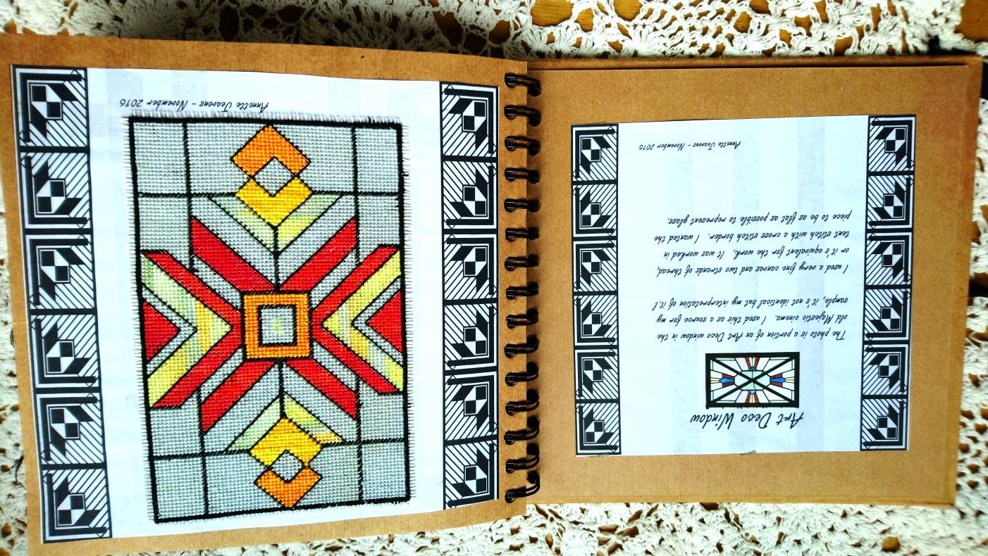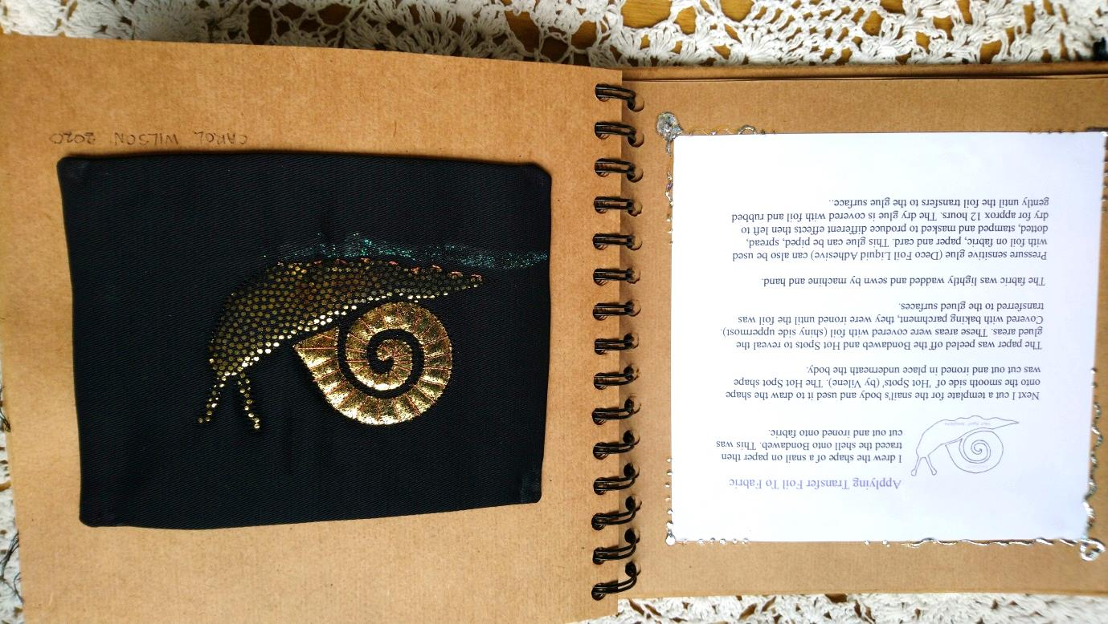

**Contents so far**

Art Deco Window by Annette Jeavons

Applying Transfer Foil to Fabric by Carol Wilson

Design Taken from a Peacock Feather by Elaine Ward

Field of Wild Spring Flowers in Crete by Kath Gaskarth

Silver Swans by Fiona Turnbull

Tatting and Even Weave by Elizabeth Jarratt

Trapunto Quilting by Fiona Turnbull

Shisha Mirrors by Charity Waistell

Mixed Media by Doris Green

Tartan Canvas by Janet Sweeting

The Dress by Judith Aird

Kantha by Elaine Ward

Canvas Work by Gloria Brunning

