Darlington Branch - September 2020

Hello Everyone,
The committee have now met twice via Zoom, an experience not without its challenges as
I’m sure many of you will testify over recent months. We were working towards our first post-COVID face to face meeting in October. A small working party visited Elm Ridge earlier this month for a site visit. We are now in possession of the Elm Ridge risk assessment for the hall and we are drafting our own branch risk assessment which will have to be agreed with Elm Ridge and which we plan to share with all members before our first meeting. Our concern is to ensure that we do everything we can to make our meetings as safe as possible whilst still making it an enjoyable experience. However, the recent new rules concerning meeting people – The Rule of 6 – adds a layer of restrictions which render meeting much more complex to arrange and potentially much less enjoyable. , but in the light of guidance from HQ – https://embroiderersguild.com/index.php?page_no=1040&page_menu=covid- 19-information – we have sadly taken the decision to cancel our plans for meeting at Elm Ridge in October. However, we are still working to complete the risk assessment in the hope that the situation will change later in the year.

New look October meeting
Not to be deterred our working party have switched our plans for October to meeting via ZOOM. Although we acknowledge that this is not ideal and that not all members are willing or able to participate via this medium, we feel that we must try this out. Please remember this will be a learning experience for all of us – unless you are a ZOOM expert, in which case please come and help.
During the last week of September those on email will receive and ZOOM invitation from Sandra, together with joining instructions and Sandra’s contact details so that we can help as many as possible to join. More details will follow.
The meeting will commence at 2pm. Please come prepared with some or all of the work that you’ve been doing during lockdown. We are also setting a challenge to decorate a face covering with stitch, not that you will have to wear it throughout the meeting, unlike the Elm Ridge option!

Branch AGM and officers
The advice from HQ is that under the current circumstances AGMs can be deferred and ranch Officers can remain in post until the AGM, provided they are willing to continue to remain in office. As mentioned in our last newsletter the committee has decided to defer the AGM at least until the end of the year, however we plan to circulate Branch Officers reports and accounts at the beginning of October for information. All the current Branch Officers are willing to remain in post for the present.

Future speakers
Joy has been busy with the programme and discussing plans with potential speakers, however it is difficult for speakers to balance concerns about COVID with their desire to deliver the type and quality of talk that they would normally aspire to, particularly when they are accustomed to circulating samples and pieces of work to their audience.
Lesley Wood, who was originally scheduled to speak at our September meeting and then agreed to come to the October meeting has now agreed to defer again to a date to be arranged. Joy had written a lovely introductory piece about Lesley’s work and what we can expect, but perhaps we should keep that until we know that she can come and join us, whenever that is possible. In the meantime, as a taster here are just two images of some of the pieces that she is planning to share with us.
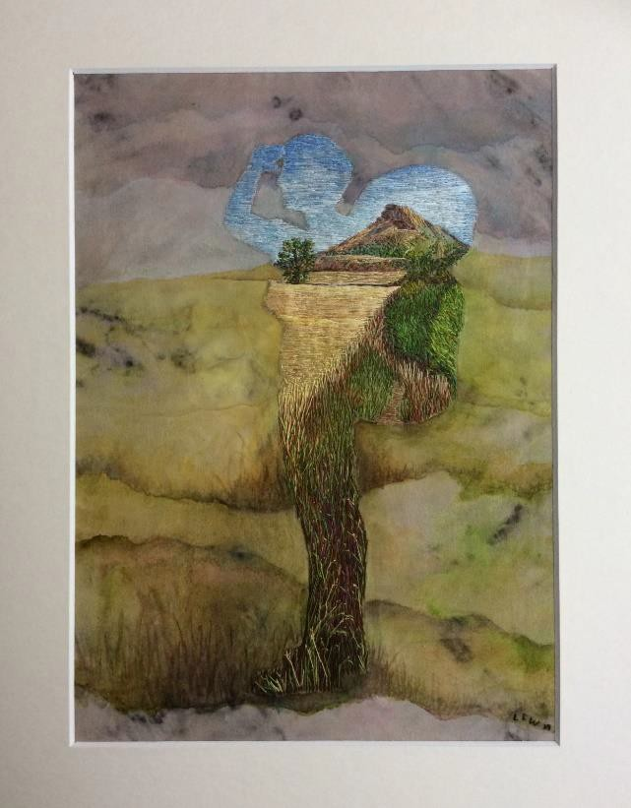
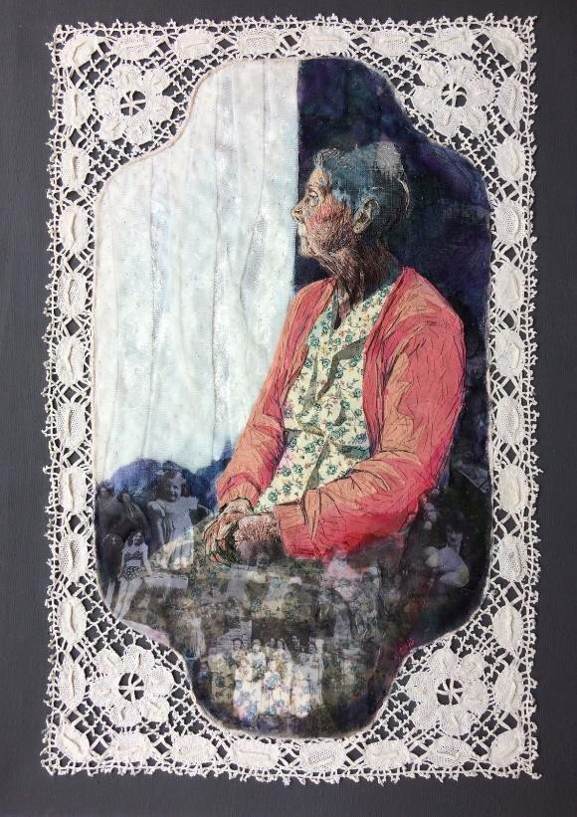

Branch Awards
As we missed the opportunity to participate in the Fletcher Award at the July meeting, we intend to try to hold this as soon as we can meet. This is open to any piece of work regardless of technique (including kits) that you have completed in the past year. A really

good opportunity to share lockdown projects. I’m sure that many of us have been working our way through collections of UFOs and PhDs.
The Festival Bowl competition, originally planned for October has been pushed back for a future date, giving you more time to finish your ‘Inspired by Folk Art’ projects.

Membership fees
The new year for membership fees begins from 1st September. If your renewal date is in September, you should have received notification by now from HQ about renewing your Guild membership directly with the Guild. If you joined later in the year, your notification will arrive in due course. Clare has a master list and can provide details and will be collecting branch membership fees at a later date.

Library opening
Julia writes - Libraries are open again. This could be useful for inspiration and techniques. Darlington has some browsing within usual opening hours. The Durham County group including Barnard Castle and Bishop Auckland have a pick and collect service only. Stockton group including Yarm and Thornaby allow browsing but with limited opening times. Dewey number to look for embroidery books is 746.44.

Website
The website is live and can be found at the following address www.embroiderersguilddarlington.co.uk
The old site is still present so ensure that you type the new address directly in the address bar to access the new one. The format is accessible from all devices. Please take a look around and if you have any images or information in a digital format that you think should be included or if anyone is interested in helping with further development of the website please contact Gloria.

Special Guild Event - A Morning with Malcolm Lochhead
Thursday 24th September from 10am - Malcolm Lochhead, textile artist and designer. Emeritus Professor of Visual Design, Glasgow Caledonian University in conversation with Marsha Gladstone: a glimpse at a creative career and a creative process.
After the presentations from 10 a.m. to 12 noon there’ll be a chance to stay online till 1 p.m. to meet Malcolm, hear about the rest of his career, and exchange your own embroidery and quilting stories. You’re also welcome to sew to your hearts’ content alongside our sessions Registration link: tinyurl.com/scojeccreativethursdays Register now to take part in this very special event - all are welcome.
https://embroiderersguild.com/index.php?page_no=168

And finally,
Last week Darlington Hippodrome announced that it is reopening its doors, so we though that we would share a little reminder of happier times and the anniversary of the opening of our ‘In the Limelight’ exhibition at the theatre last year.

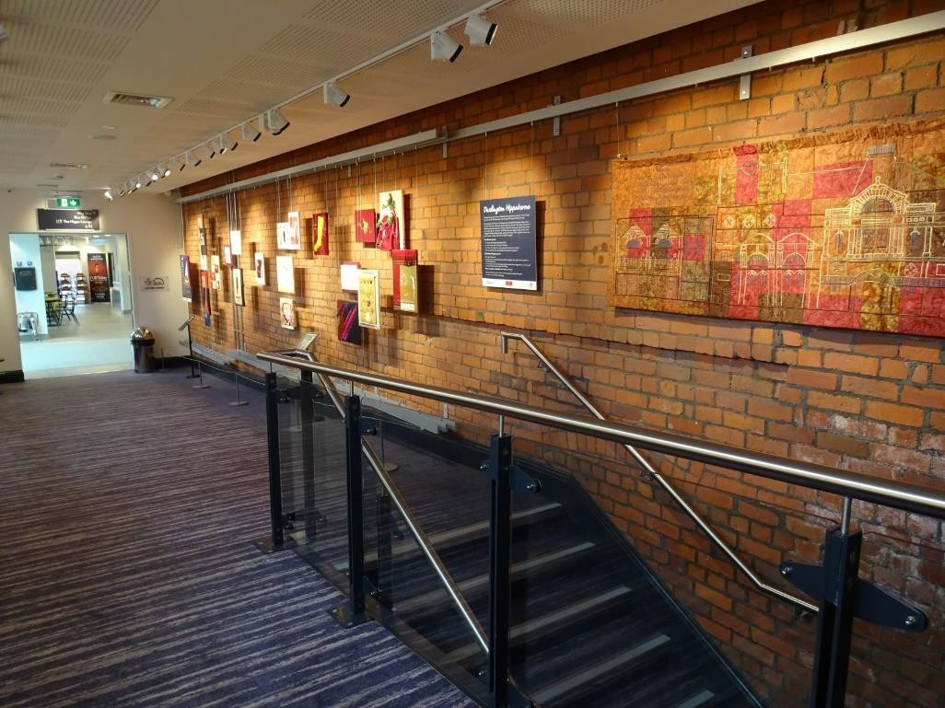

With best wishes,
Julia, Sandra, Clare and Joy

Darlington Branch website www.embroiderersguilddarlington.co.uk
Darlington Branch Facebook page: www.facebook.com/DarlingtonEG

Darlington Embroiderers’ Guild is compliant with current regulations relating to data handling and storage (GDPR May 2018)

